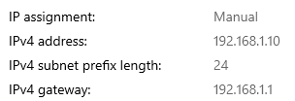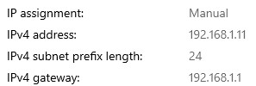  
  
All pings were successful.

Some ports were up because they had a cable connection while the ones that were down had no connection to them.

A ping could be prevented by a firewall, a bad route, or an improper connection.